**EdgeStar IB120SS Ice Size Adjustment**

If you need to adjust the ice size on your IB120SS Ice Maker for any reason, it can be done in a few simple steps.

**NOTE: You should unplug your icemaker before following the procedure below**

1. Remove the white plastic cap on the end of the ice making module (the green part of the machine where the ice is produced):

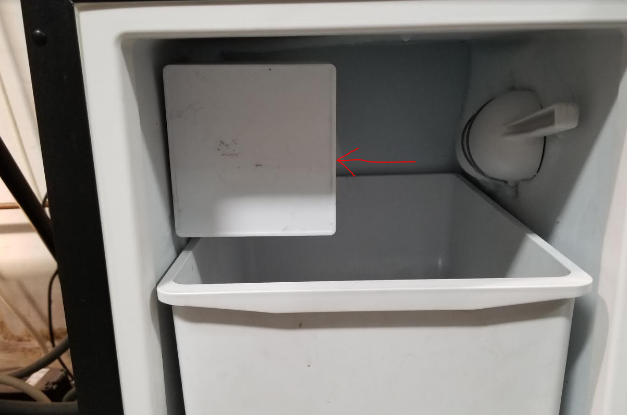

1. Locate the ice size screw and turn it one turn at a time. Turn it counter clockwise to reduce the cube size or clockwise to increase the cube size:

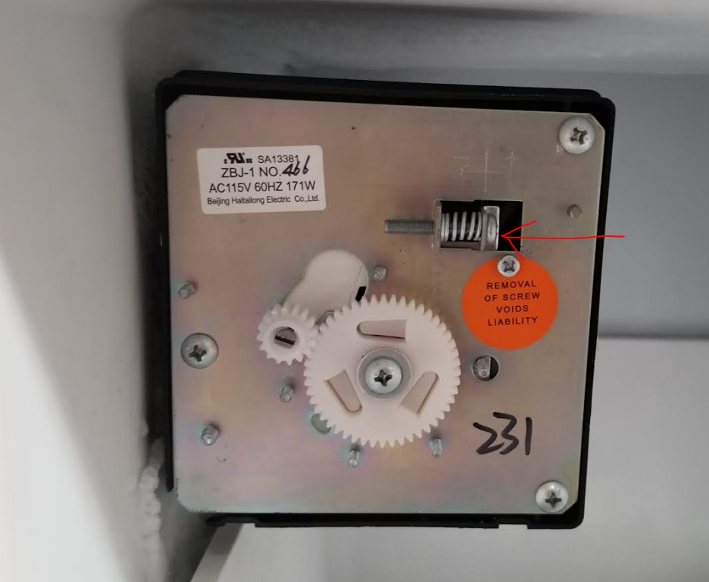 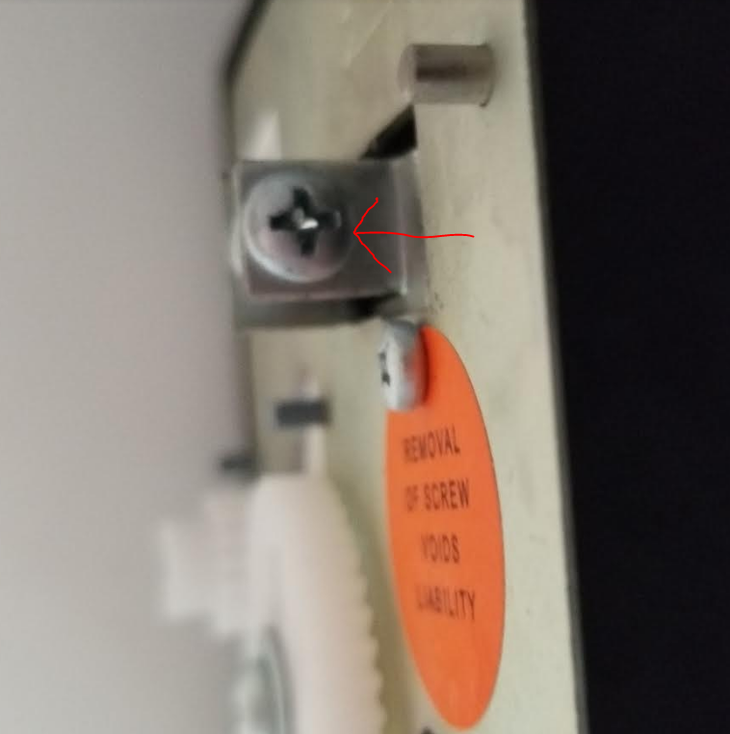

1. To inspect the results, let the machine make several batches of ice. It may take 3 or 4 batches to fully see the results of the adjustment. If ice is stuck in the module, let the unit defrost overnight or until the ice melts enough to fall away from the module.