45 Lbs. Ice Maker – Ice Full Light On
(IB450SS, IB450SSP, KIM450SS, OIM450SS)

Sometimes on the 45 lbs. ice makers, the ice full light will be illuminated when the ice bin is not 100% full. If this occurs the first thing to check is the ice slideway. The ice slideway has a magnet on the end that makes contact with the switch. As long as the magnet is making contact, the unit will be allowed to make ice when the ice making mode is selected. If the magnet is not making contact, the ice full light will illuminate. The slideway is normally pulled away from the switch with ice sitting on the two tabs going down into the unit.

In instances where the magnet is not touching the switch but the bin is not full, sometimes there is a burr on the plastic ice slideway and it is not allowing it to rotate freely. See the image below for an example of the ice slideway:
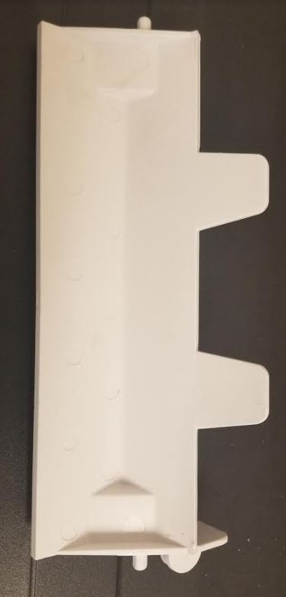
On the right in the above image, you can see the round magnetic piece that contacts the ice full switch.

When the ice bin is not full, the slideway will look like the below image:
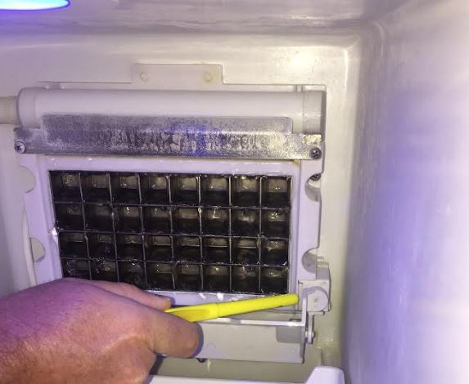

When the ice bin is full, ice will hold the slideway down and the switch portion of the slideway will look like this image:
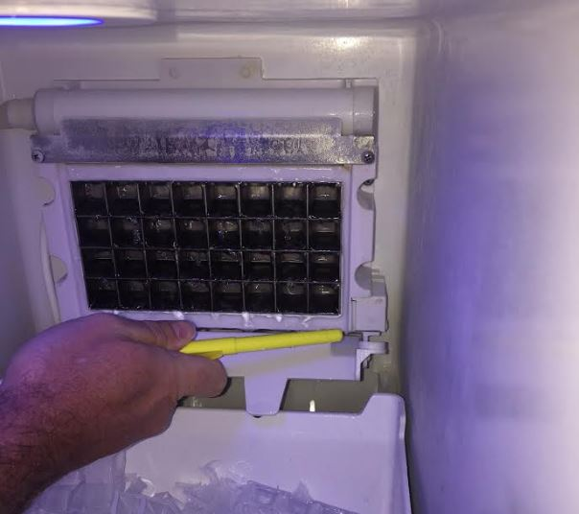

If there is no ice holding the slideway down as in the above image, there may be a burr causing the slideway to not rotate freely. You can flip the slideway up into position and verify that the ice full light shuts off and the unit goes back into ice making mode. If this works as intended, you may need to clean the burrs off of the plastic ends on the slideway with some sand paper or a nail file. See the image below for an example of where there are burrs causing the slideway to get stuck:
